B. In-Depth Explanation & Analysis
1. Bohr’s Model vs. Quantum Mechanical Model Students often conflate "orbits" and "orbitals."
- Orbit (Bohr): A well-defined circular path (like a planet around the sun). It violates the Uncertainty Principle.
- Orbital (Quantum): A 3D region where probability of finding an electron is max (90-95%). It respects the Uncertainty Principle.
- Analogy: An orbit is like saying "The student is exactly at desk 5." An orbital is like saying "The student is likely somewhere in the classroom."
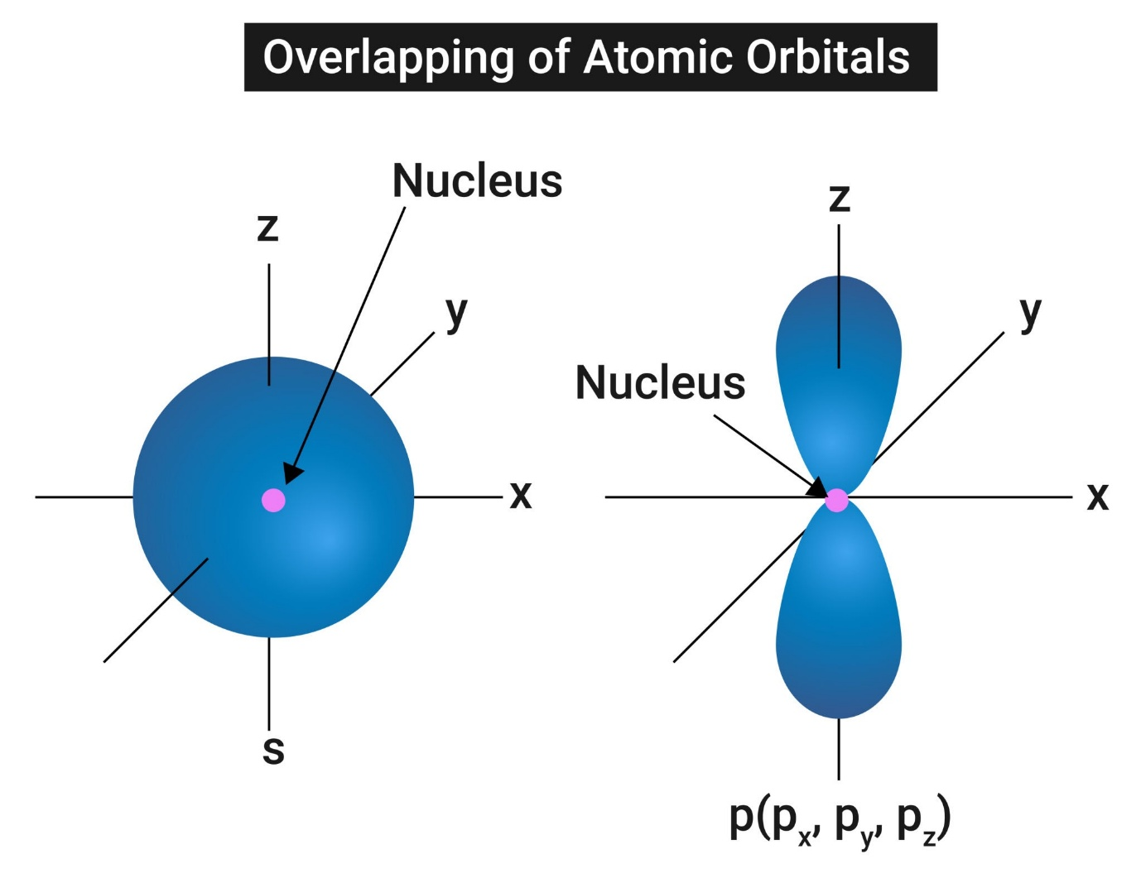
2. Quantum Numbers (The Address of an Electron) Think of this as a postal address for an electron.
- Principal ( $n$ ): The City (Shell/Energy Level). $n=1,2,3…$
- Azimuthal (l): The Street (Subshell). $l=0$ to $n-1.(0=s,1=p,2=d,3=f)$.
- Magnetic ( $m_{l}$ ): The House Number (Orientation of Orbital). $-l$ to $+l$.
- Spin ( $m_{s}$ ): The Person (Spin state). $+1/2$ or $-1/2$.
3. Electronic Configuration & Stability
- Aufbau Principle: Electrons fill lower energy orbitals first. Order: $1s<2s<2p<3s<3p<4s<3d..$. (Note: $4s$ fills before $3d$ due to lower $n+l$ value).
Mentor insight: To figure out the priority of energy orbitals simply add the number of the principal shell(n) with the value of the subshell (s,p,d or f).For example, 3p- 3+1=4
- Exceptions (Crucial for Exams): Chromium ( $Cr,Z=24$ ) and Copper ( $Cu,Z=29$ ).
  - Expected Cr: $[Ar]4s^{2}3d^{4}$. Actual Cr: $[Ar]4s^{1}3d^{5}$.
  - Reason: Half-filled ( $d^{5}$ ) and fully-filled ( $d^{10}$ ) subshells possess extra stability due to symmetry and exchange energy.
4. Dual Nature & Uncertainty
- de Broglie: $λ=\frac{h}{p}=\frac{h}{mv}$. This implies that a moving cricket ball does have a wavelength, but it is too small to observe. Electrons, being tiny, have significant wavelengths
- Heisenberg: You can't take a clear photo of a speeding electron. If you focus on position ( $Δx$ small), the momentum gets blurry ( $Δp$ large).

